PCM
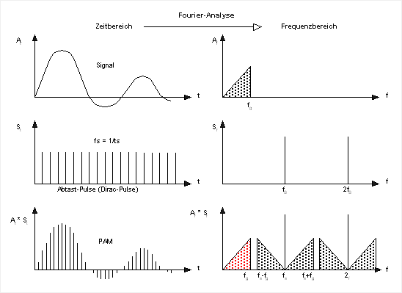
Puls Code Modulation

Pulse-code modulation (PCM) is a method used to digitally represent analog signals.
PCM is used for digital audio in computers, Compact Discs and telephony.

At the Sender the input signals are sampled (measured) in regular intervals and then the resulting numbers are transmitted to the receiver’s side. The receiver takes the numbers and transforms them back to an analog voltage.

For telephony the most common standard is G.711 (www.itu.org)

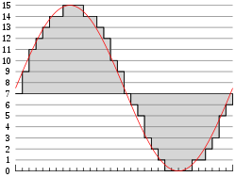
Sampling frequency:
The sampling frequency has to be more than twice of the highest signal frequency!
In telephony a low pass-filter with a cut-off-frequency of 3,4 kHz is used to limit signal bandwidth. The Sampling Frequency in G.711 is 8kHz.

Accuracy:
Accuracy of digitizing (measuring) analog signals is limited by the number of bits of the analog to digital-converter.

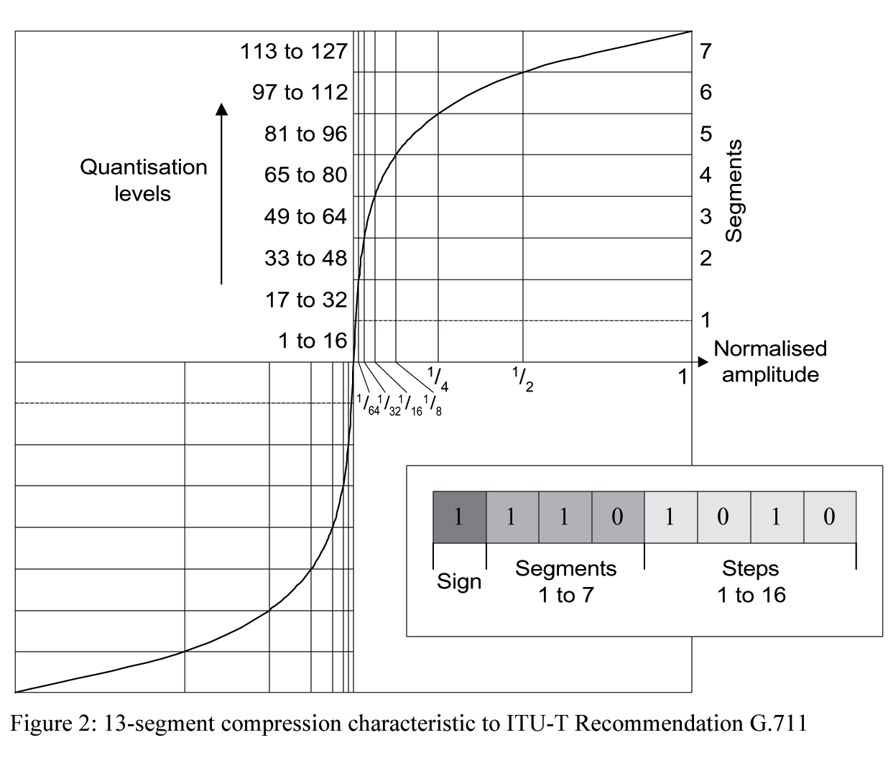
In G.711 only 8 bits are used but the steps are not distributed equally.
A logarithmic compressing LAW A-Law (Europe) or µ-Law (USA) rules the mapping of analog voltages to the digital numbers. At the receiver the signal is expanded again by a digital to analog converter using the same COMPANDING-Rule.

The Chip performing A/D and D/A conversion is named CODEC.
The needed lowpass filters at the sender and the receiver are also located on this Chip

Time division multiplexing
Time division multiplexing is used to transmit more than one speech channel on a transmission channel. The transmission channel is divided in separate timeslots for transmitting one speech channel per timeslot.
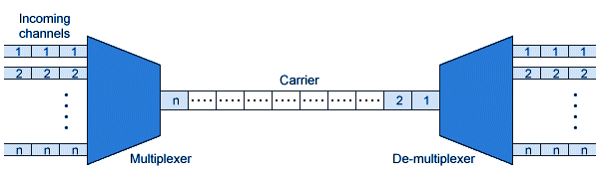
PCM30
PCM30 uses 32 timeslots for transmission of 30 speech channels every 125µs. Channel 0 is used for synchronization and timeslot 16 is used for signalling purposes.
The resulting data stream is 2.Mbit/s
32 timeslots of 64kb/s.
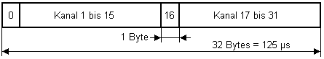

ITU-Standard G.732 describes time multiplex for PCM 30 used in Europe named E1
USA uses PCM 24 wit 1.544 Mb/s named T1 instead of PCM30.

If more than 30 channels need to be transmitted on one transmission channel higher order TDM is used.
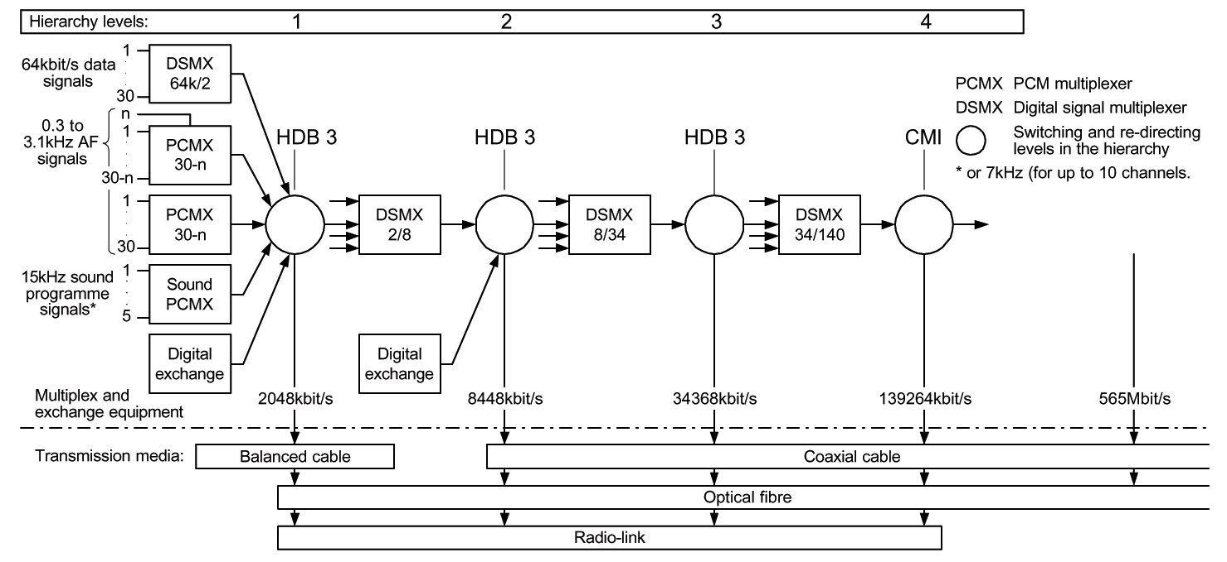
Switching

Switching is to connect the correct speech partners. Chips named memory time switch are used for this purpose.
PCM-Highways with up to 128 Channels per highway interconnect several codecs to each other and those PCM-highways are connected to a memory time switch.
Signals coming in from the PCM-Highways are stored sequentially in the speech memory of this time switch.
Connection memory stores pointers to speech memory for every output timeslot on every output-highway. There is a way for a microprocessor to write to the connection memory so the microprocessor rules which signal is used for any output channel.

With this method it is possible to connect any input signal to any output signal of a memory time switch.

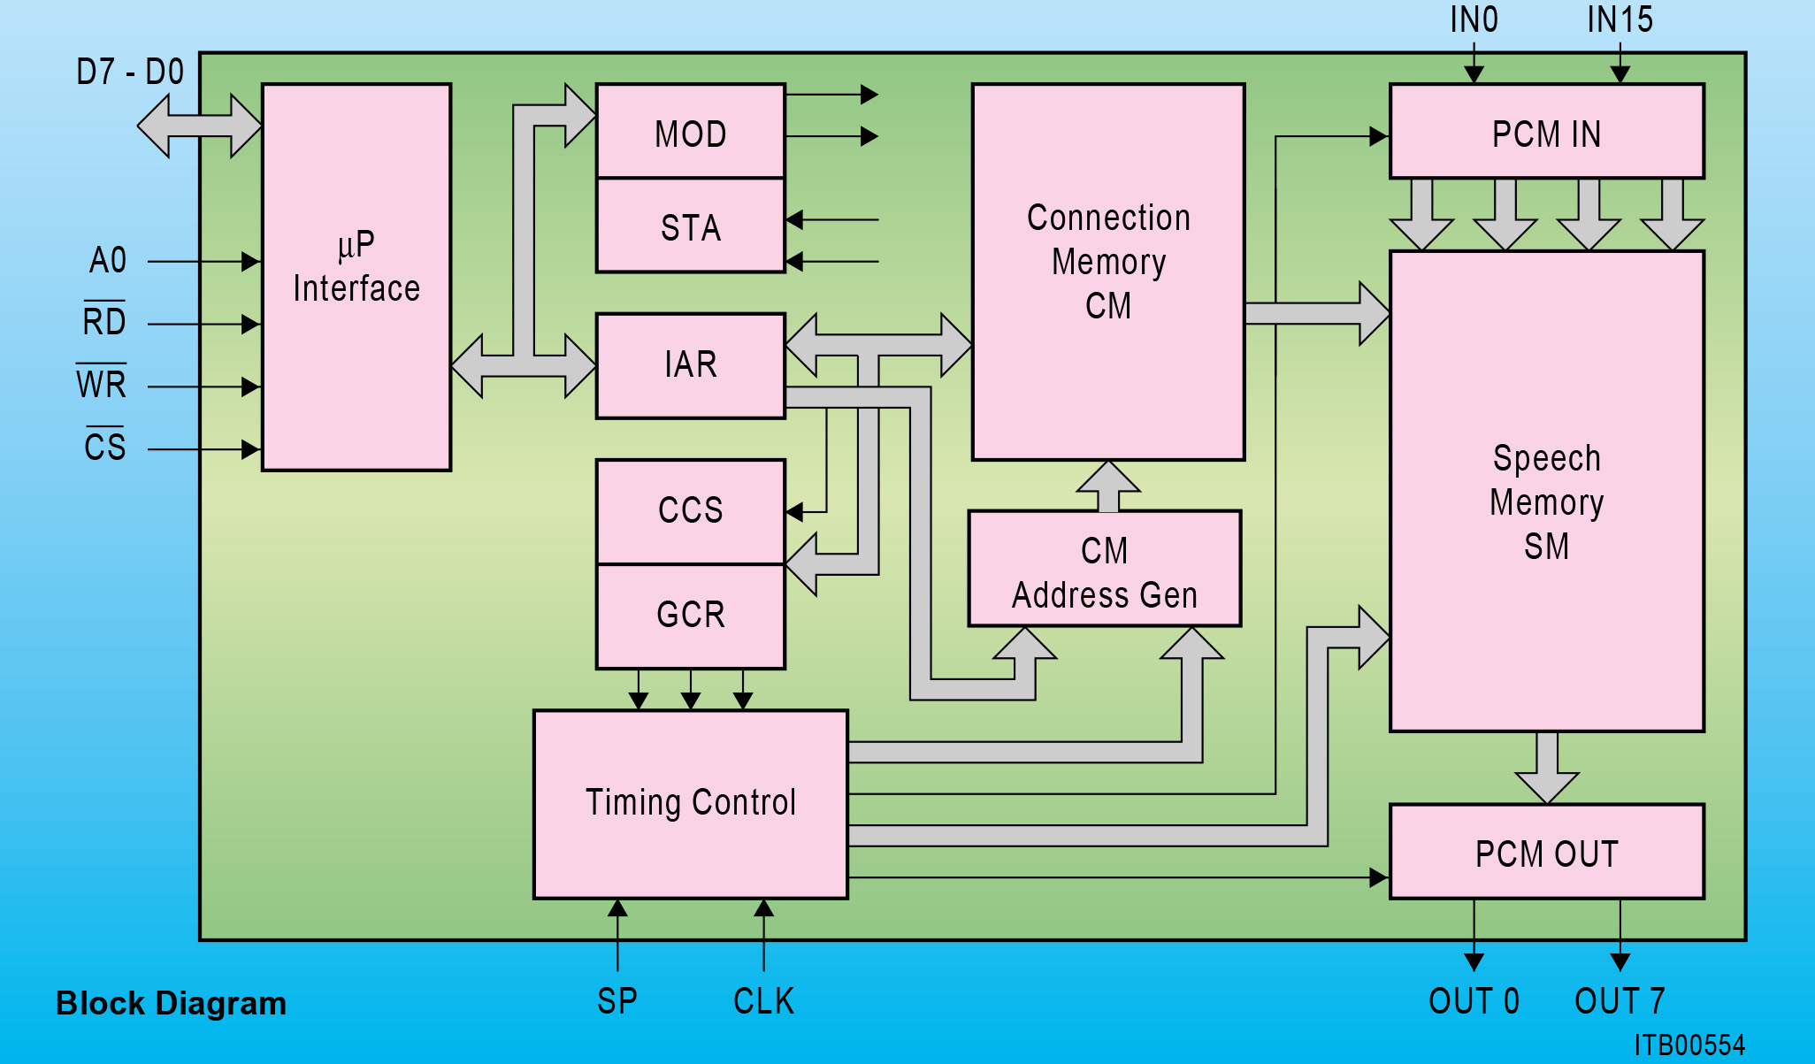

Source coding
The purpose of source coding is to reduce the necessary bit-rate needed for transmission of a Signal.
Most commonly used source coding in telephony is the ITU-Standard . G711
G.711 was introduced in the 1970´s. Today more sophisticated methods using more advanced technology like signal-processors are available.

ADPCM
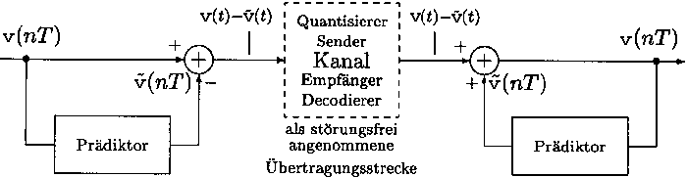
ADPCM is a method to reduce needed transmission bandwidth by reducing redundancy in the signal. The key device in ADPCM is a predictor trying to predict the next sample using the history of samples transmitted before.
Two predictors with the same algorithm are located one at the sender and one at the receiver. So both predictions are equal.

The sender then measures the difference between the predicted signal and the real signal.
This difference is transmitted to the receiver.
The used prediction algorithms work very well for speech signals so that less information is needed to transmit only the differences instead of the whole signal.
ADPCM is standardized by ITU in the standard G.726.
ADPCM is used in Digital European Cordless Telephony with a transmission bandwidth of 32kb/s.

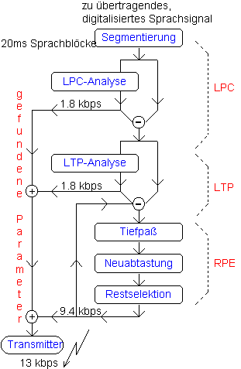
GSM 06.10

Mobile phones are using a more sophisticated method of voice compression that combines two methods:
Linear Predictive Coding
And Runtime Pulse Excitation.
The resulting bit rates used are:
- full rate 13kb/s
- half rate 5,7kb/s

practice: comparison of different speech coding algorithms
record following signals by use of a souund card :
Signal Nr. | 1 | 2 | 3 | 4 | 5
frequency | 450Hz | 4500Hz | 450Hz | 450Hz | 450Hz
level | 0dB | 0dB | -30dB | -30dB | -30dB
Sample rate | 8kHz | 8kHz | 8kHz | 8Khz | 8kHz
resolution | 16Bit | 16Bit | 8Bit | A-law | 32kB/s ADPCM

Programs to use:
Audiotester:
Audiotester is a program building an audio-Laboratory with the use of a sound card.
Audiotester provides you with a frequency generator a Oscilloscope and a spectrum analyser using the soundcard (sound chip) .
Before measuring signals with Audiotester the PC has to be calibrated using the frequency generator (line out) connected to audiotesters oscilloscope (line in). Calibrating means that the mixer is set to the maximum level that is possible without clipping.
Cool Edit Pro
Cool Edit pro is a waveform editing program providing Waveform recording, analysis and storage of the recorded waveforms in different coding standards like PCM, A-and µ law and ADPCM. The effect of different coding methods can be investigated by storing a recorded waveform and compare the stored and re-opened signal file with the original waveform.

Answer following questions:
- Which of the test signals generate aliasing effect?
- Noise (distortion) value at low level signals -30db
using: 16 Bit linear PCM, 8 Bit Linear PCM, 8-bit A-Law, 8Bit ADCM

